**CN5006 Lab Session Week 5 Portfolio**

**Prepared by:Radhe Shyam Yadav  
Date: *29-oct-2024***

**Tutorial Overview:**  
With a practical approach to developing functional components and putting dynamic user interfaces into practice, this lab session focusses on the foundations of React programming. By the end of the course, I knew how to work with components, properties, and events and create simple React apps. An outline of the main learning goals and assignments finished during the lab is provided below.

To create react application there are the two method to create react application in the lab tutorial week 5. So I went through first method.

In the method 1 I used console to run the npx command

You can see the screenshot of when we run the command npm init

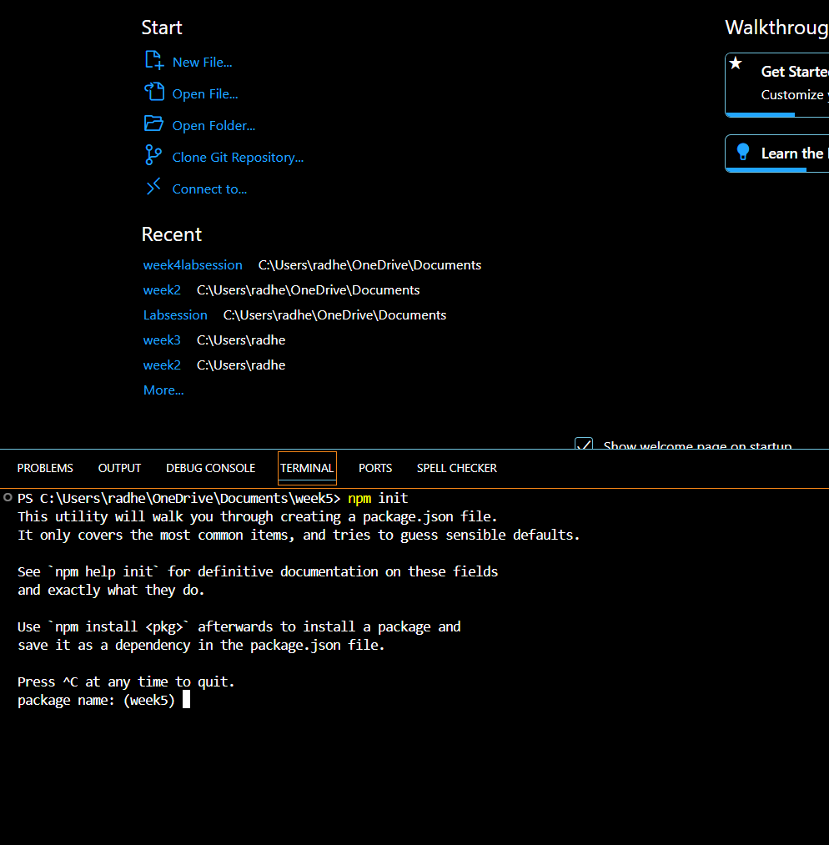

Now its turn to create my app using npx create-react-app in the new terminal.

Here is the screenshot of the creating the react app.

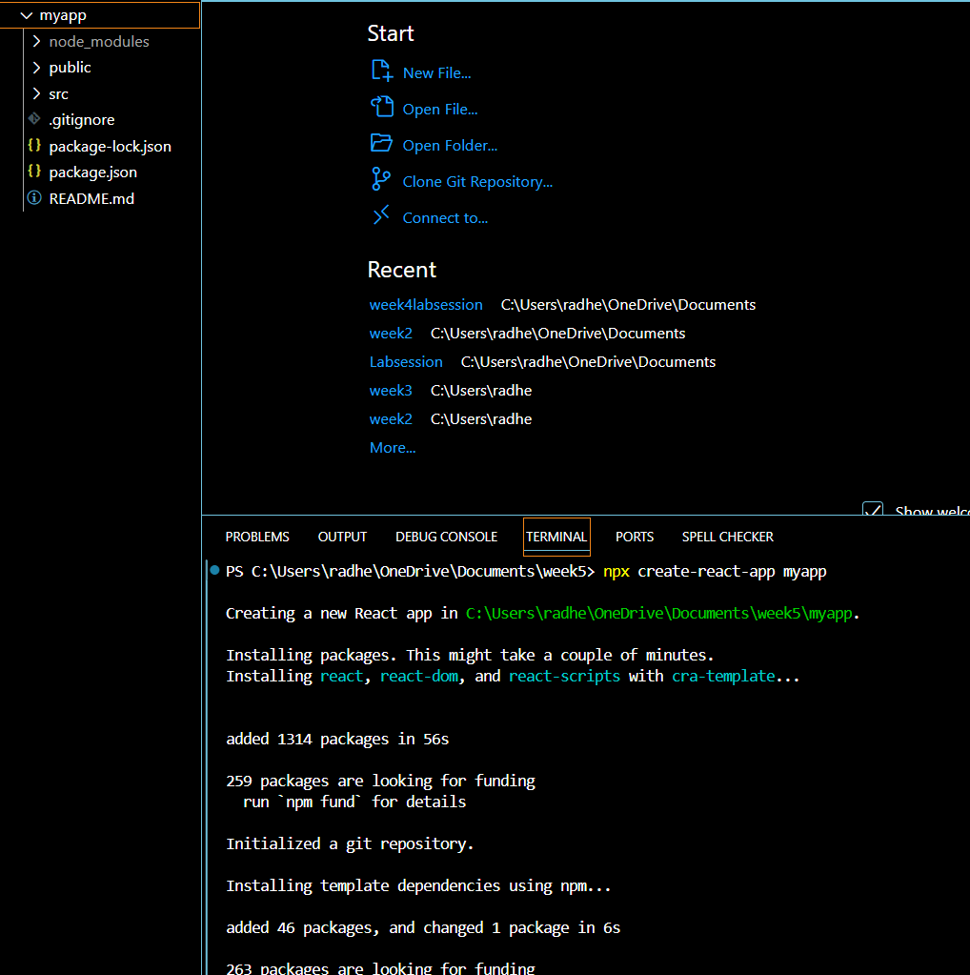

Here I am going to start my application using npm start in new terminal window